Te Araroa Waitako Regional Trustee Information Pack
July 2021

What is Te Araroa?
Te Araroa is New Zealand’s national walking trail, traversing 3,000 kilometres of stunning scenery as it winds its way from Cape Reinga in the far north to Bluff at the bottom of the South Island.
Opened in 2011, it has been rated among the top long walks in the world by CNN and National Geographic for its scenic beauty and the way it connects walkers with New Zealand communities, cultures and historic sites.
During the 2019-2020 walking season (October-April) the number of people walking the entire length of the trail exceeded 1,200 for the first time. Hundreds of thousands more walked individual sections in their weekends, during their holidays, or at the end of the day as part of their weekly exercise regime.
Walking the trail provides people with an immense sense of achievement, as well as significant mental and physical health benefits. The growing number of walkers is also making an immense contribution to the many communities the trail passes through by boosting regional economies, re-invigorating towns and enabling local businesses to thrive.
Te Araroa Trust is the kaitiaki (guardian) of the Trail, responsible for developing, promoting and managing the trail for the good of New Zealand.
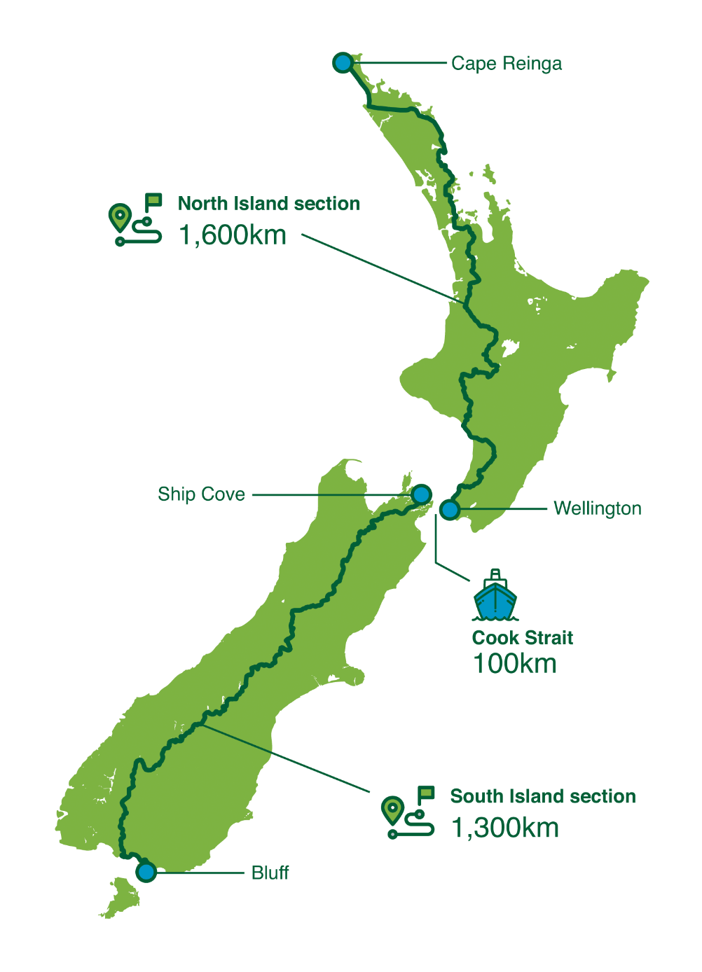

High Level History
1975 – The New Zealand Walkways Commission is formed. One of its goals is a New Zealand-long “scenic” trail.
1983/84 – A NZ Taranaki man Rex Hendry did a wilderness walk that explored a possible route for a long NZ trail.
1987 – The New Zealand Walkways Commission is folded into the Department of Conservation without having achieved a long trail.
1994 – Te Araroa Trust is formed after a newspaper article by Geoff Chapple advocating a New Zealand-long trail.
1995 – First trail Kerikeri-Waitangi opened by then Prime Minister Jim Bolger.
1997 – Te Araroa Trust maps a North Island route in consultation with local and regional councils en route, and DoC Conservancies.
1998 – Geoff Chapple walks the North Island route to prove viability, to test land-owner response, to raise funds, and heighten the project’s profile. He writes one of the first weblogs which becomes popular, and the trail idea begins to take hold.
1999 – Te Araroa Trust gets a Millennium grant and hires a construction manager and work teams for its first linking track down the Waikato River.
2002 – Te Araroa Trust maps the South Island trail, again with extensive consultation, and Geoff Chapple walks the trail, and tests land-owner responses en route.
- Te Araroa Trust signs an MoU with the Department of Conservation under which DOC agrees to assist Te Araroa Trust with a continuous tramping corridor east of the Southern Alps.
- The Mayors Taskforce, led by Christchurch mayor Garry Moore adopts Te Araroa as a “priority project.” Over 20 councils en route begin to co-operate.
2003 – Te Araroa - The New Zealand Trail a book published on the trail, wins ‘Environment category’ Montana book award.
- Regional Te Araroa Trusts established to co-ordinate volunteer effort. Eight regional trusts in total, including Southland, Otago, Canterbury/West Coast.
- Te Araroa is not open, but walkers begin to do it anyway – up to 10 a year, using roads as by-passes where necessary.
2006 – New Te Araroa tracks now total over 400km. The links through to legal thoroughfares on the coast and river margins, make over 80% of the route walkable, including a 15% back-road component. Local authorities begin to put Te Araroa into district plans and regional authorities include it in regional walking strategies. Crown Tenure Review results extend the SI trail.
2007 – DOC is voted $3.8 million to put in Te Araroa across public estate – previously Te Araroa had financed such tracks. Te Araroa Trust, its eight regional trusts, with co-operation from territorial local authorities and regional authorities continue to develop all sections outside the public estate – two thirds of the distance.
2008 – New track openings and access to previously inaccessible legal thoroughfare makes over 90% of the trail walkable, including the road component which has now been shrunk to 13.5%. Not all of that 90% is signed - just another job to be done. Te Araroa Trust plans for an opening at the end of 2011.
2011 - Te Araroa officially opened by the Governor-General Sir Jerry Mateparae on 3 December 2011. The publication Te Araroa: A Walking Guide to New Zealand's Long Trail is released.
2012 - Geoff Chapple stands down as CEO of Te Araroa Trust and is subsequently honoured with an ONZM in the Queen’s Birthday Honours. Rob Wakelin assumes the role of CEO.
2014 - Te Araroa Trust opens the Puhoi Track, a track specifically built for day-walkers to experience Te Araroa.
2015 - Te Araroa Trust receives a Walking Access Award from the New Zealand Walking Access Commission, in recognition of what they have achieved in opening up many locations for public walking access.
2015 - Te Araroa Trust and DOC agree a further $1.6million funding to conclude the construction programme over the next two years.
2016 - Te Araroa Trust opens the Paekakariki Escarpment Track, a $1.4million project between Paekakariki and Pukerua Bay, another track specifically aimed at day-walkers
2018 – Rob Wakelin steps down as CEO after five years, Mark Weatherall is appointed as the Trusts CEO.
2020 – Te Araroa Trust partners with Waking Access New Zealand

Te Araroa Trust Strategy
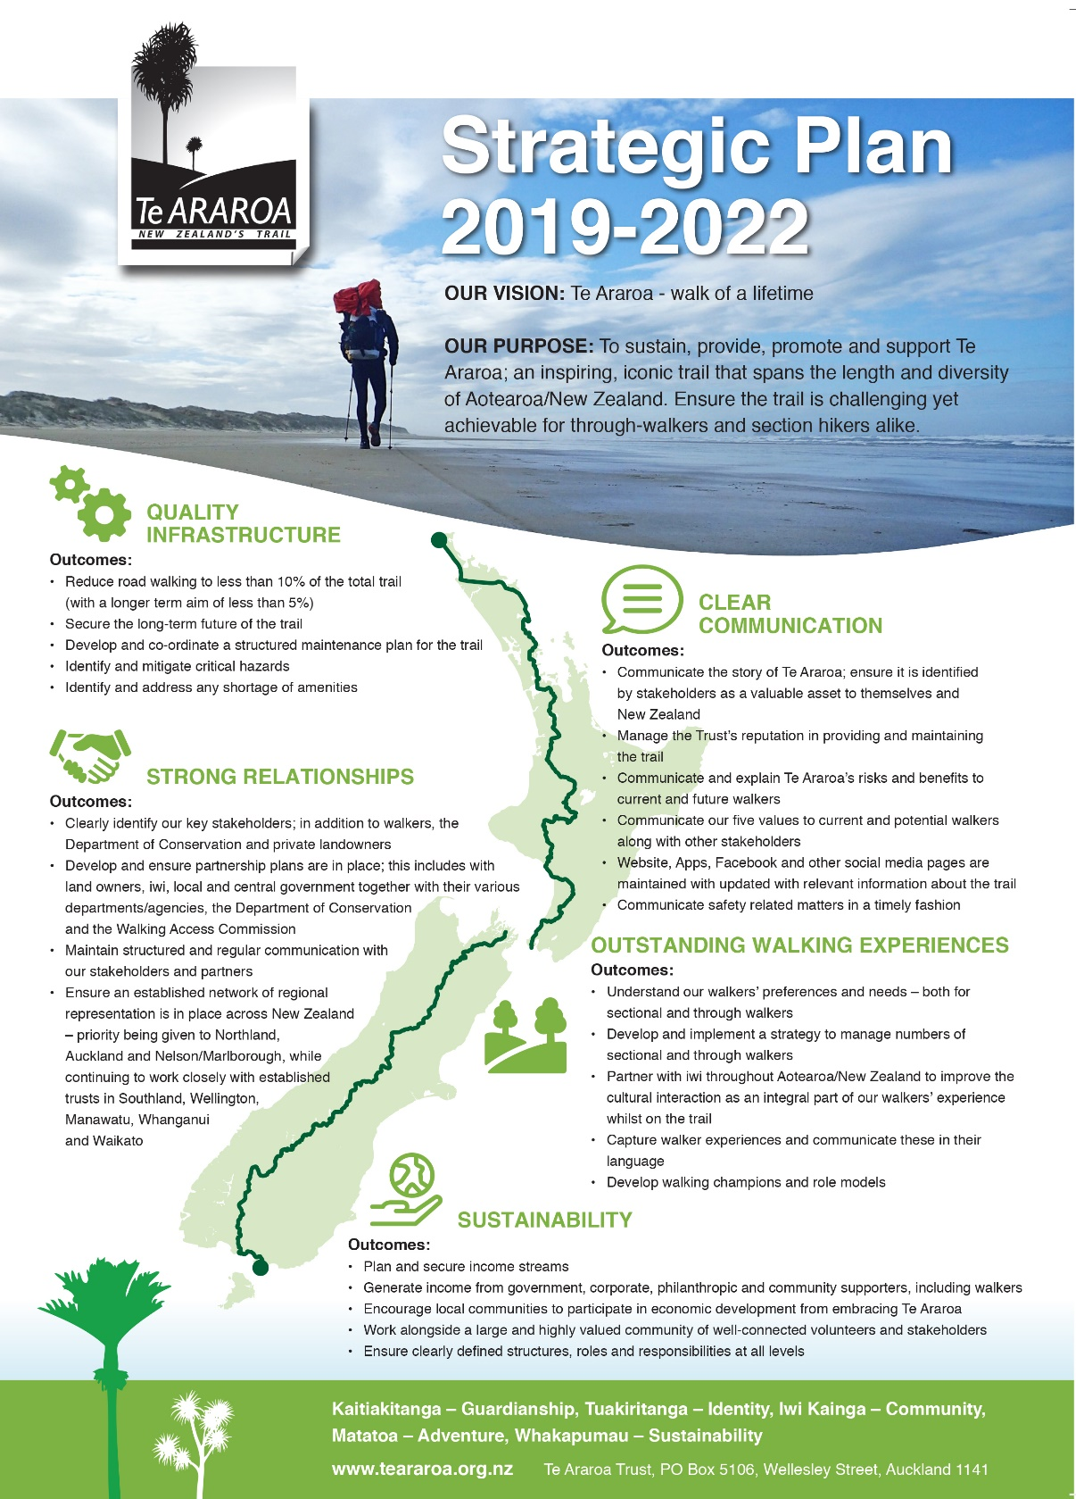
Position Description – Te Araroa Waikato Regional Trust

Our Vision: “Walk of a lifetime”
Reports to: Te Araroa Waikato Regional Trust Chairperson
Purpose of the trust: To sustain, provide, promote and support the Te Araroa trail in the Waikato region, an inspiring, iconic trail that spans the length and diversity of Aotearoa / New Zealand. The trail is challenging yet achievable for through-walkers and section hikers alike.
Scope of the position:
The appointed Trustees are fully accountable members of the Te Araroa Waikato Trust and is expected to exercise the powers and perform the duties of the Trust as set out in the Constitution of the Te Araroa Trust and adhere to the Te Araroa Trustee Code of Conduct.
Appointment and tenure
The Trustee’s will be appointed for an initial three (3) year term at the conclusion of they are eligible to stand again. The application process for the role will be managed by the appointment panel.
Time Commitment
The Trust will meet on a six-weekly basis, there may be some work required in between the meetings, but the expectation is not large.
Personal Attributes and Skills
General:
- To see the big picture and the implications and impact on issues in the broader sense
- To make sensible, astute recommendations and business decisions
- To interpret both factual and conceptual information and make sound judgements based on that information.
- To contribute to the creation and not merely the preservation of stakeholder value; and to be able to distinguish between the separate but complementary roles of governance and management.
- Ability to network and connect people.
Strategic:
- To hold all the interconnecting components of strategy and planning together and to develop and drive a cohesive work programme to achieve Te Araroa’ s vision and purpose.
- To understand the position of the Te Araroa Waikato Trust, its market and its relationship to key stakeholders
- To look beyond the short-term and ensure that the trust adopts a longer-term, stewardship approach.
Analytical:
- To interpret financial statements and statistical information and the significance and meaning of appropriate performance indicators
- To question and probe information, assumptions and assertions in a quest for improved understanding and better decision-making.
- To remain objective and measured under pressure.
Social:
- To participate actively and harmoniously, respecting and valuing the contributions of others and contributing to effective teamwork
- To articulate a point of view in a coherent and persuasive manner without dominating the Trust’s proceedings
- The strength of character to maintain an independent point of view when others disagree.

